# 1并发编程

知识点：

* 线程安全
* 线程封闭
* 线程调度
* 同步容器
* 并发容器
* AQS
* J.U.C

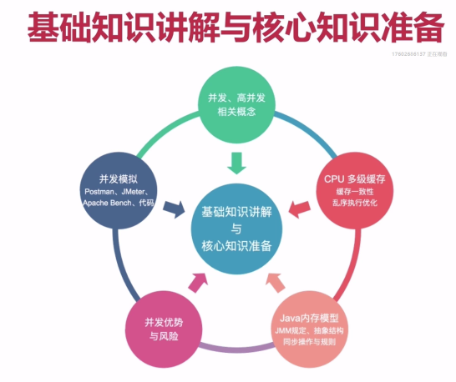

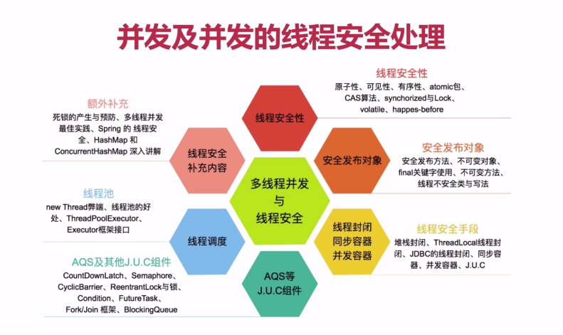

## 基本概念

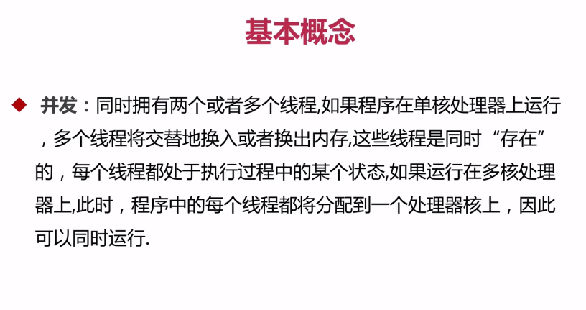

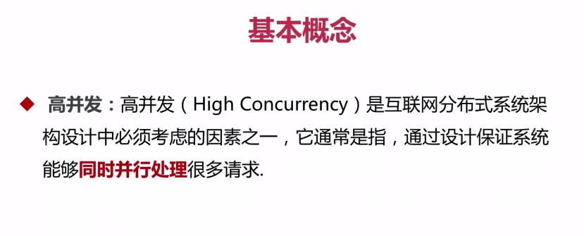

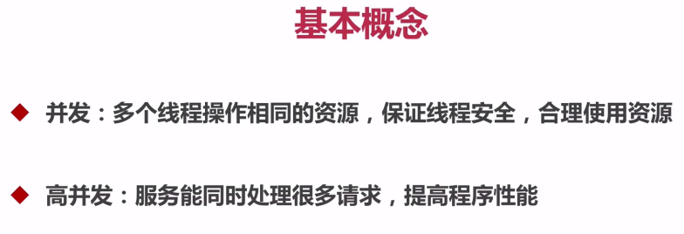

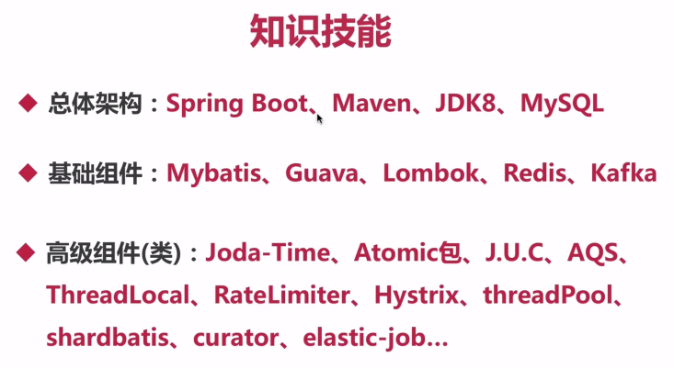

## CPU多级缓存

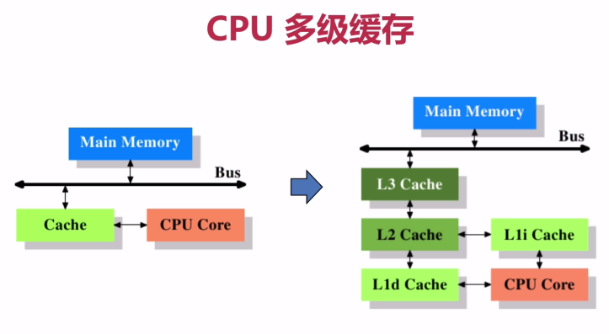

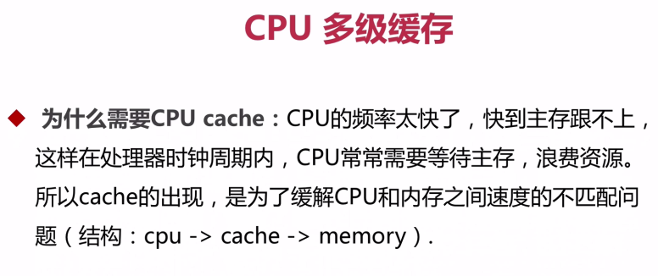

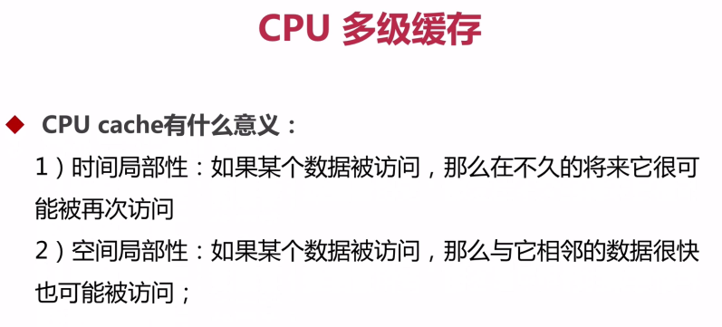

**缓存一致性协议**

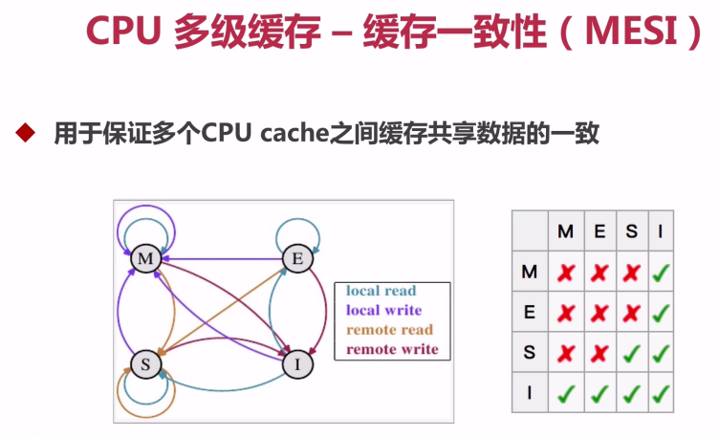

缓存的4中状态：

M：修改状态

E ： 独享

S: 共享

I : 作废

## 代码顺序优化

处理器执行优化

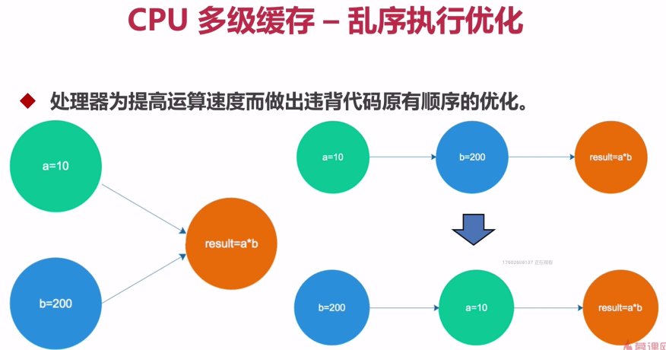

## JMM（Java内存模型）

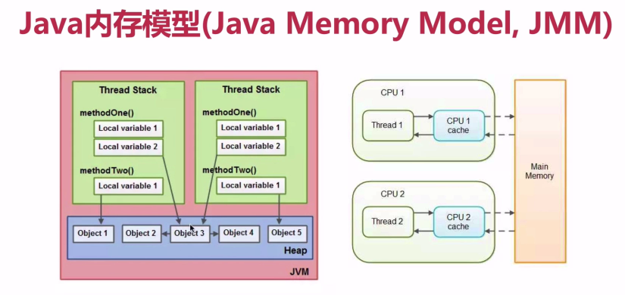

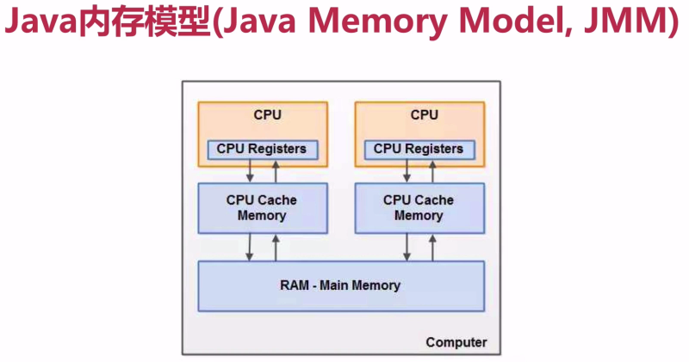

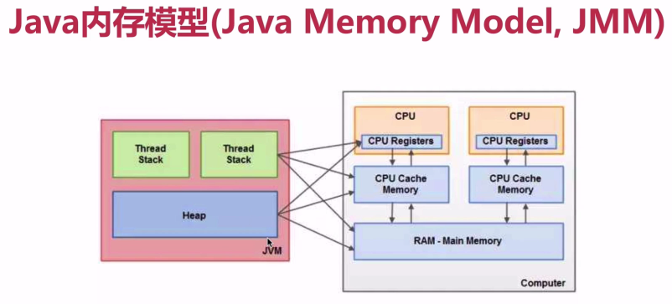

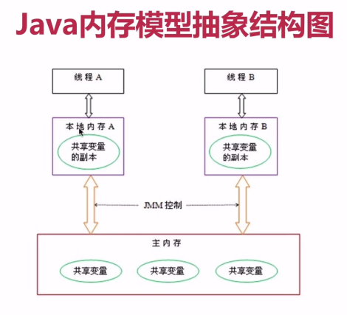

## JMM8种同步操作

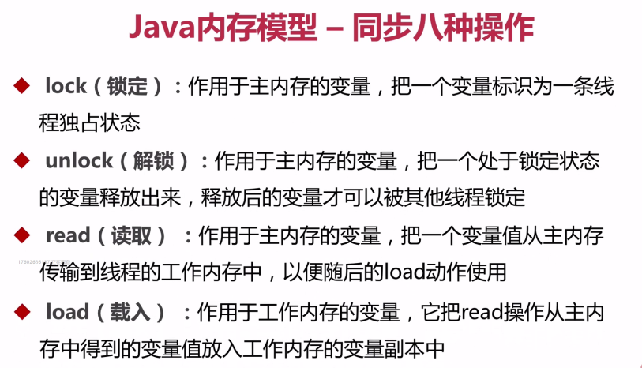

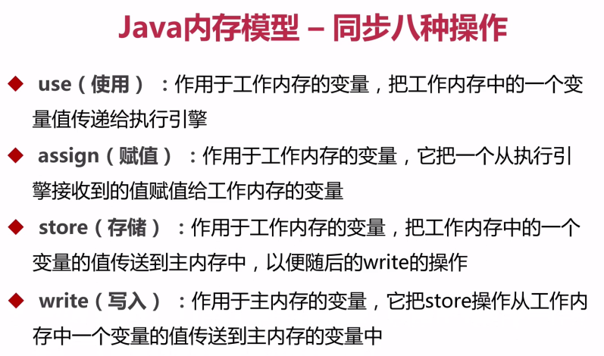

## JMM同步规则

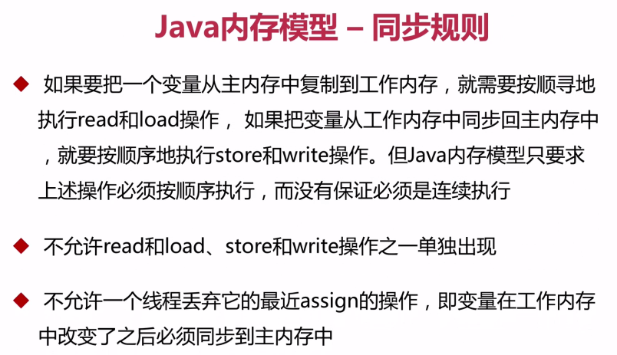

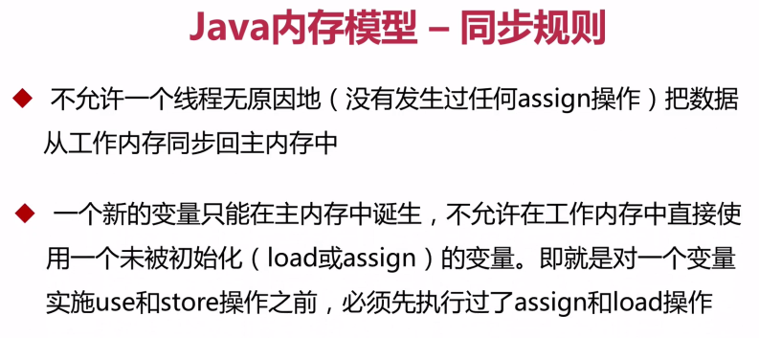

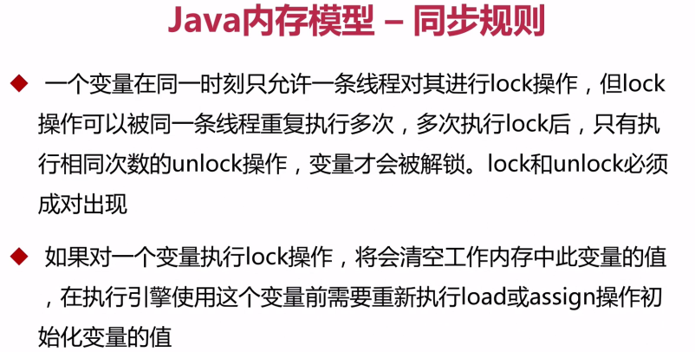

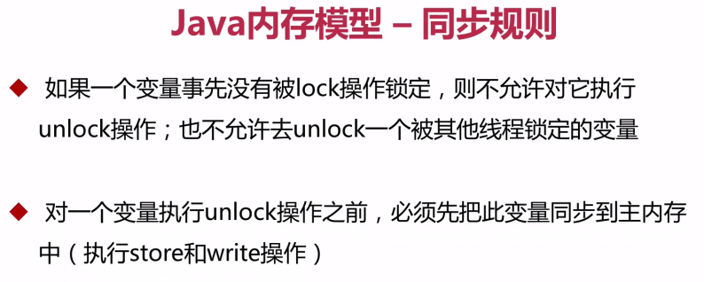

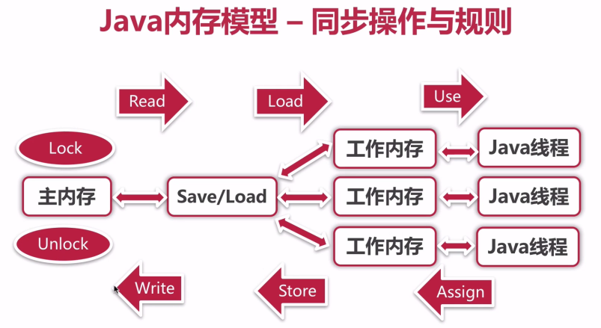

**Read happenes-before Load**

**Store happenes-before Write**

## 并发的优势与风险

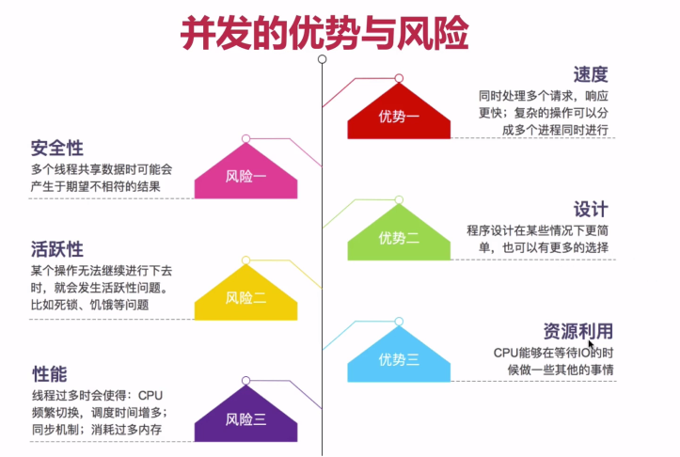

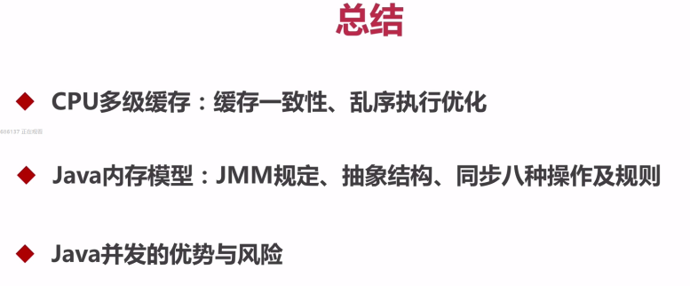

## 并发的模拟

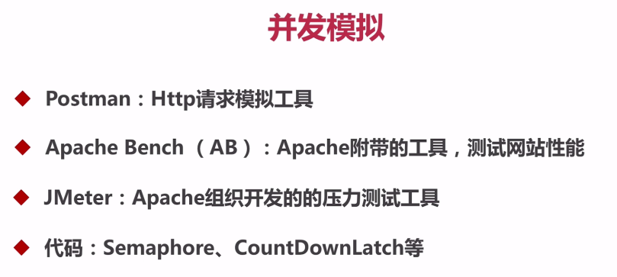

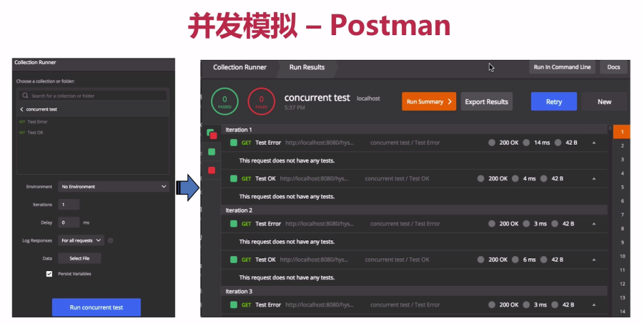

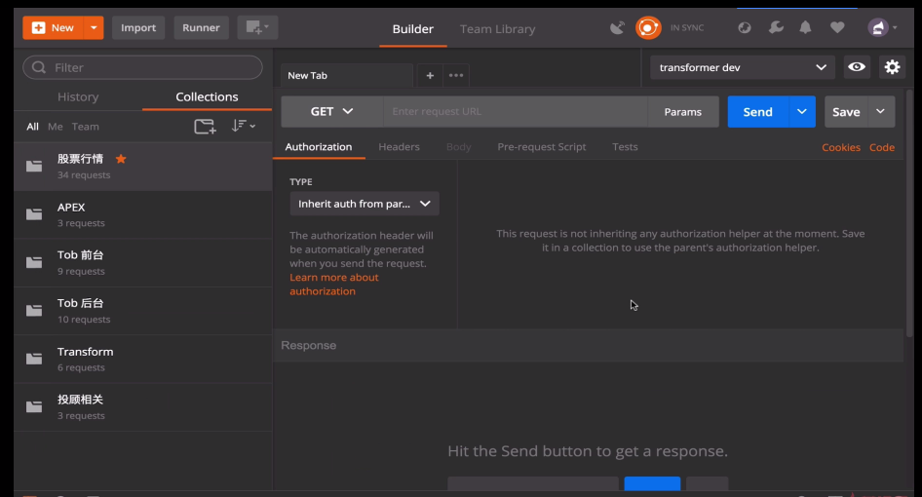

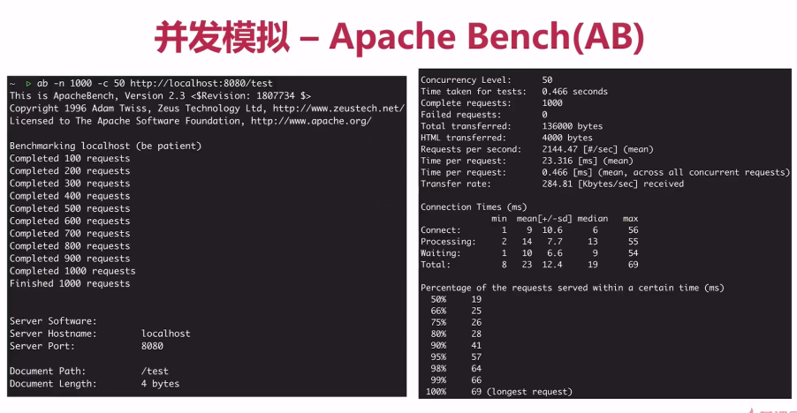

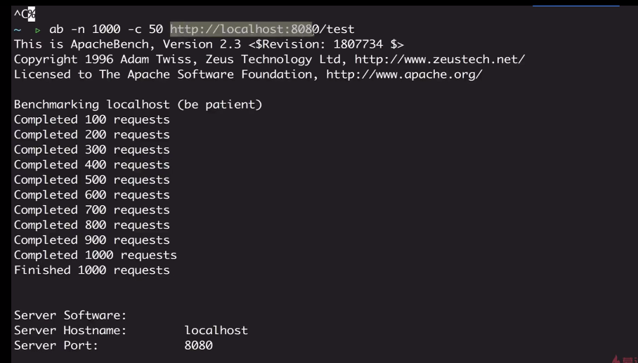

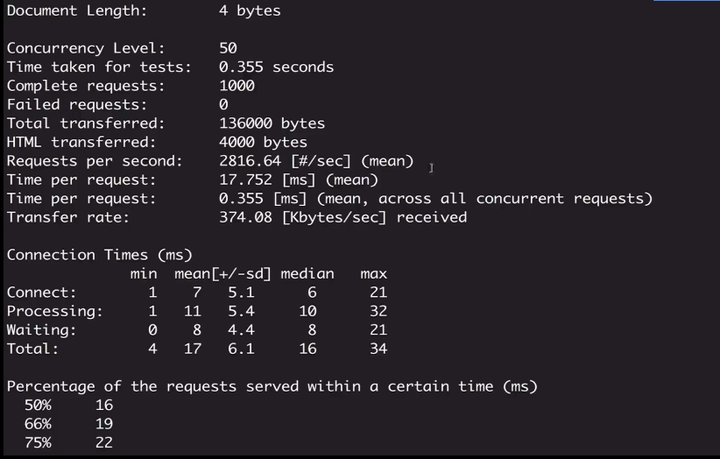

**Requests per second: 吞吐率 = Complete requests / Time taken for tests**

**吞吐率和并发量有关系，并发数不同，吞吐率不同**

Apache-jmeter(性能测试)

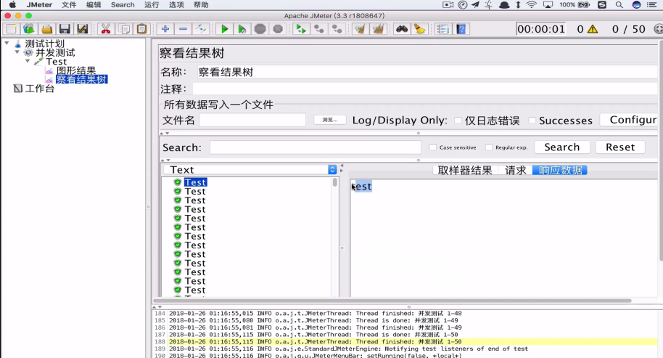

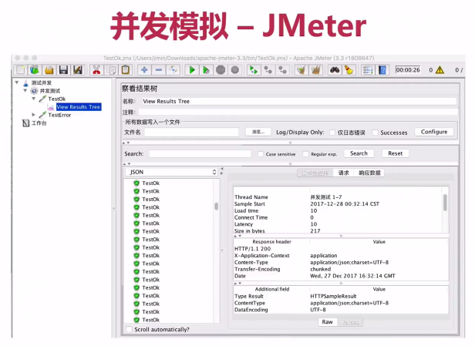

## 代码模拟并发

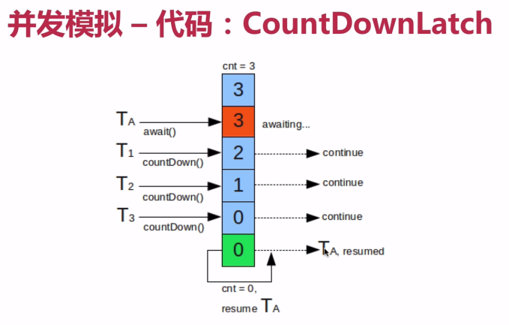

**Semaphore 信号量**

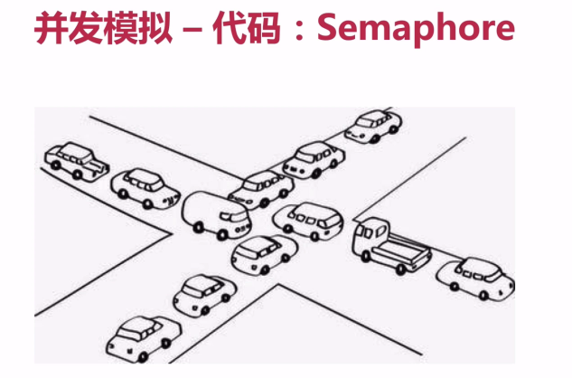

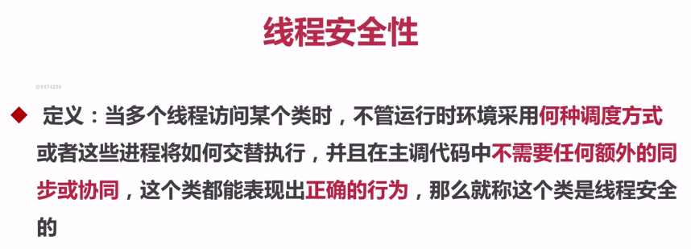

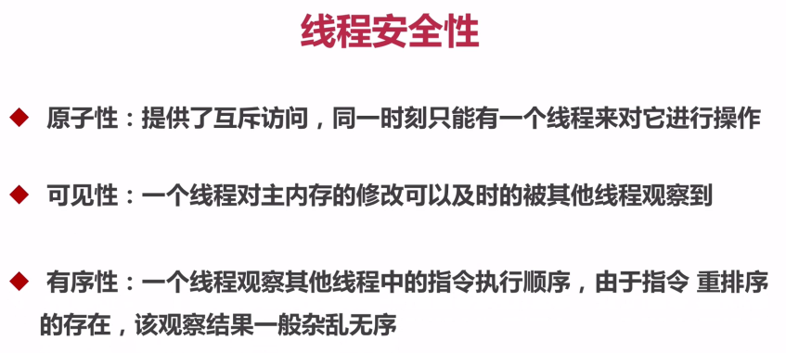

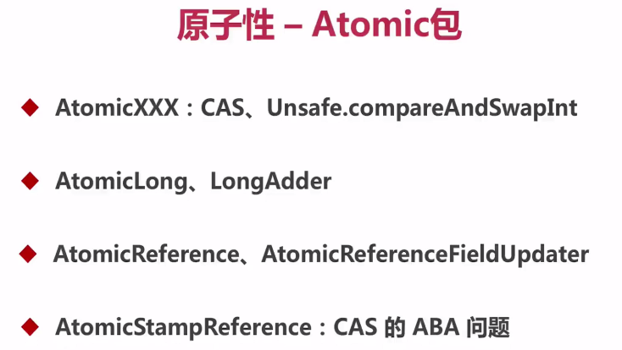

**CAS**

**Compare And Swap**

**Unsafe.java**

**Public final native int compareAndSwapInt(Object var1, int var2, int var4)**

**CompareAndSet**

```java

**private static** AtomicInteger *count* = **new** AtomicInteger(0);

*count*.incrementAndGet();

*/**  
 * Atomically increments by one the current value.  
 *  
 \** ***@return*** *the updated value  
 */***public final int** incrementAndGet() {  
 **return *unsafe***.getAndAddInt(**this**, ***valueOffset***, 1) + 1;  
}

**public final int** getAndAddInt(Object var1, **long** var2, **int** var4) {  
 **int** var5;  
 **do** {  
 var5 = **this**.getIntVolatile(var1, var2);  
 } **while**(!**this**.compareAndSwapInt(var1, var2, var5, var5 + var4));  
  
 **return** var5;  
}

AtomicStampReference

*/**  
 * Atomically sets the value of both the reference and stamp  
 * to the given update values if the  
 * current reference is {****@code*** *==} to the expected reference  
 * and the current stamp is equal to the expected stamp.  
 *  
 \** ***@param expectedReference*** *the expected value of the reference  
 \** ***@param newReference*** *the new value for the reference  
 \** ***@param expectedStamp*** *the expected value of the stamp  
 \** ***@param newStamp*** *the new value for the stamp  
 \** ***@return*** *{****@code*** *true} if successful  
 */***public boolean** compareAndSet(V expectedReference,  
 V newReference,  
 **int** expectedStamp,  
 **int** newStamp) {  
 Pair<V> current = **pair**;  
 **return** expectedReference == current.**reference** &&  
 expectedStamp == current.**stamp** &&  
 ((newReference == current.**reference** &&  
 newStamp == current.**stamp**) ||  
 casPair(current, Pair.*of*(newReference, newStamp)));  
}

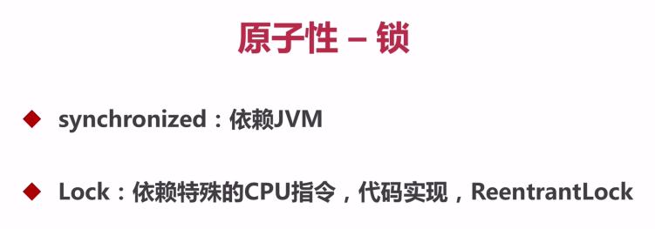

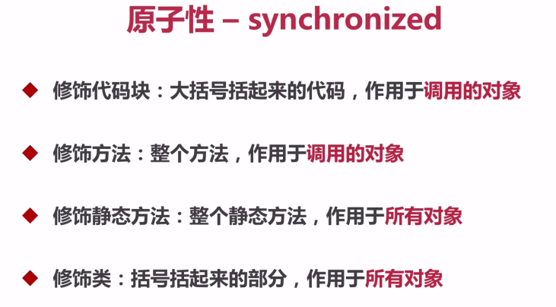

```

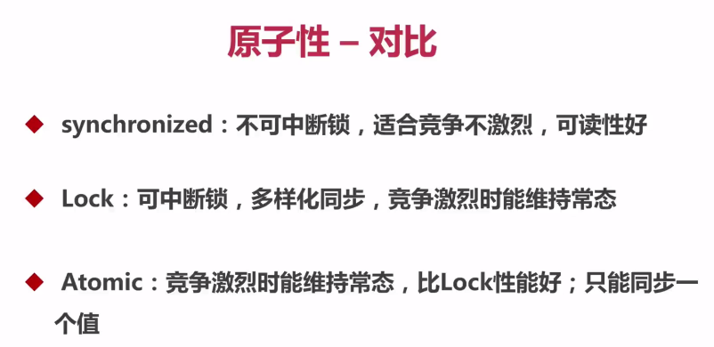

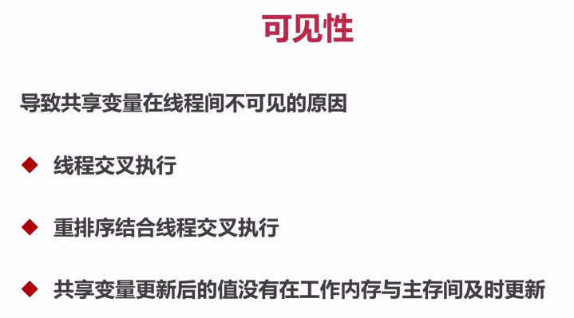

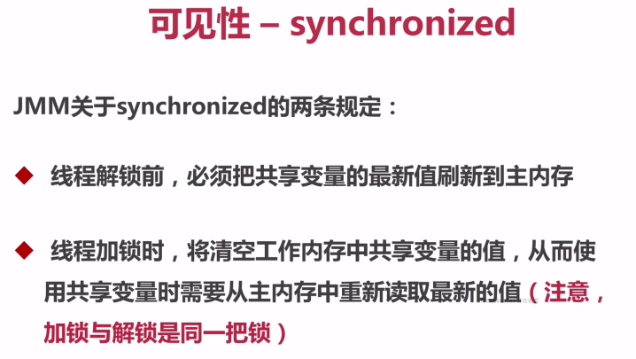

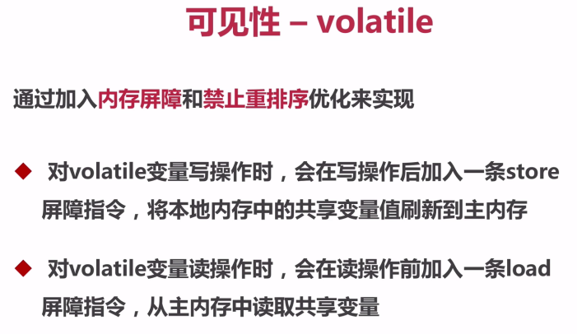

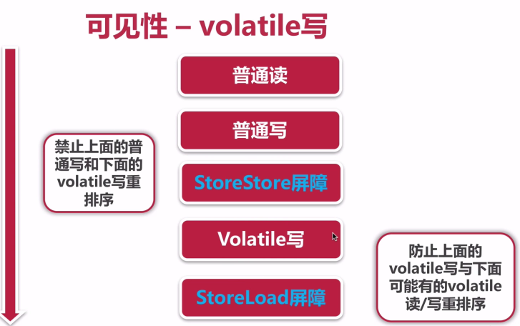

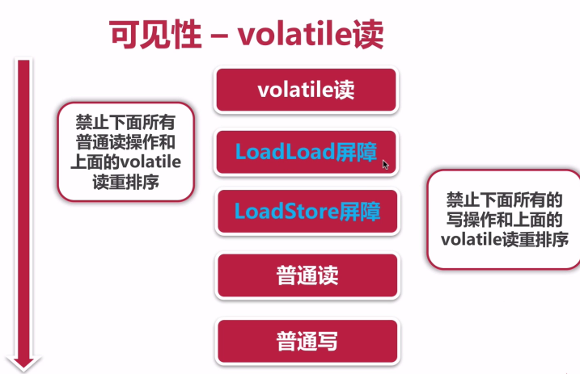

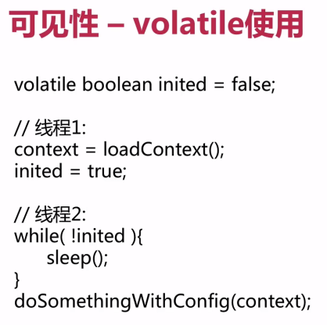

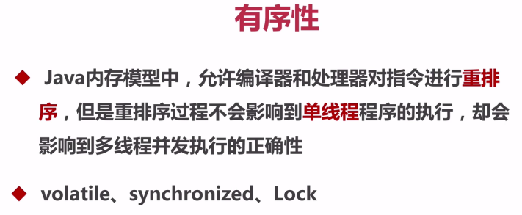

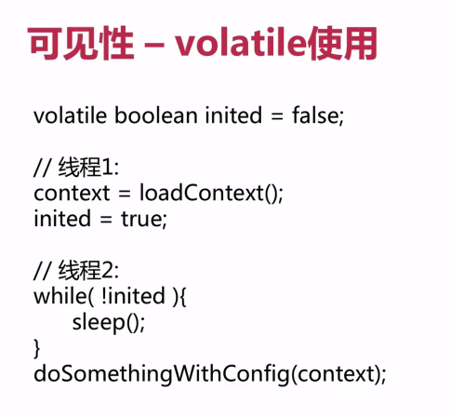

## Happends-before原则

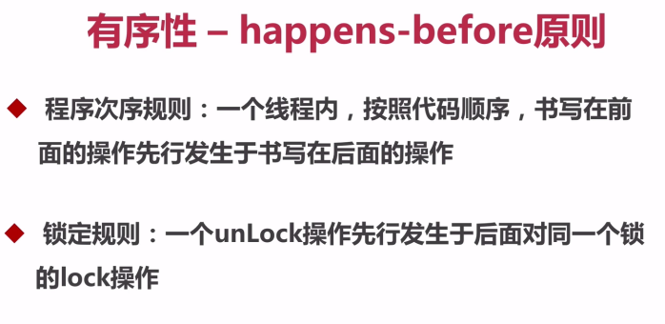

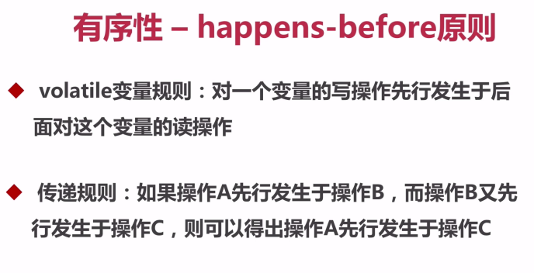

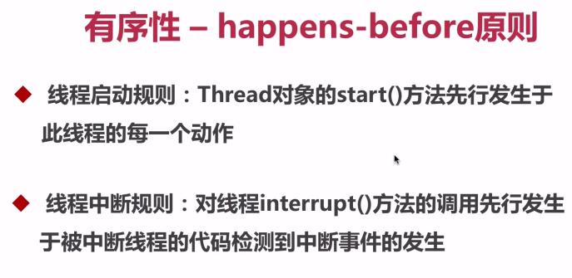

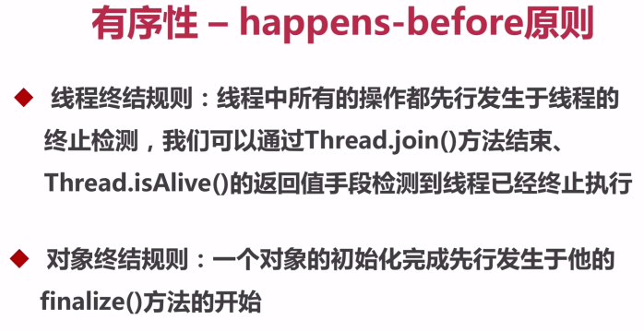

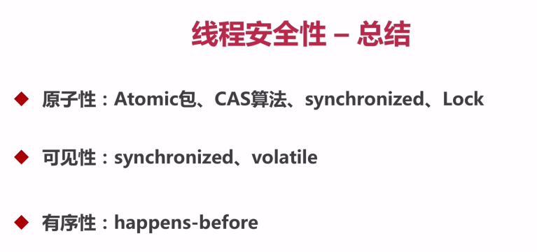

## 发布对象

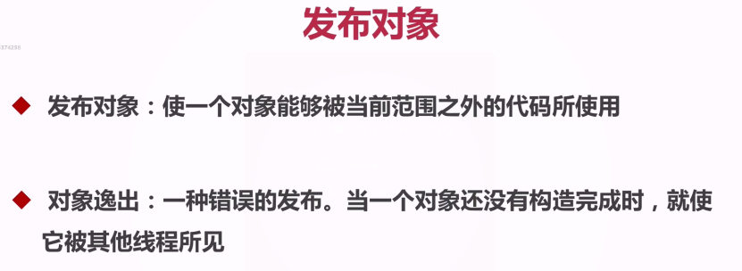

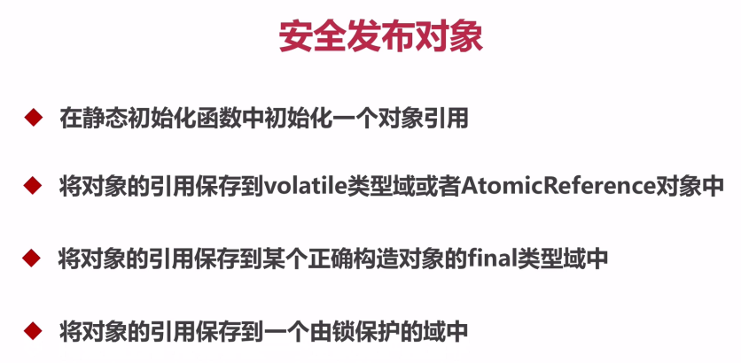

## 不可变对象

String 类

Final修饰的类

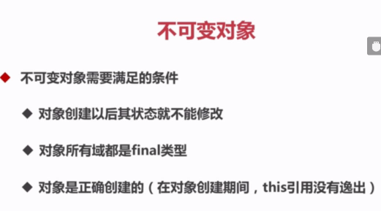

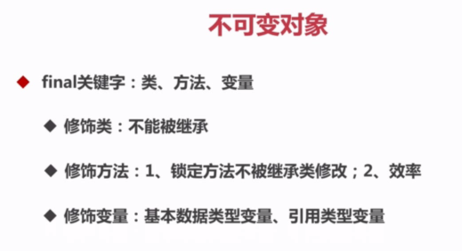

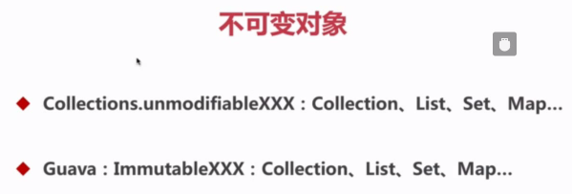

*/**  
 * Returns an unmodifiable view of the specified map. This method  
 * allows modules to provide users with "read-only" access to internal  
 * maps. Query operations on the returned map "read through"  
 * to the specified map, and attempts to modify the returned  
 * map, whether direct or via its collection views, result in an  
 * <tt>UnsupportedOperationException</tt>.<p>  
 *  
 * The returned map will be serializable if the specified map  
 * is serializable.  
 *  
 \** ***@param <K>*** *the class of the map keys  
 \** ***@param <V>*** *the class of the map values  
 \** ***@param m*** *the map for which an unmodifiable view is to be returned.  
 \** ***@return*** *an unmodifiable view of the specified map.  
 */***public static** <K,V> Map<K,V> unmodifiableMap(Map<? **extends** K, ? **extends** V> m) {  
 **return new** UnmodifiableMap<>(m);  
}

Exception in thread "main" java.lang.UnsupportedOperationException

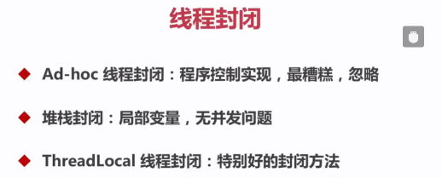

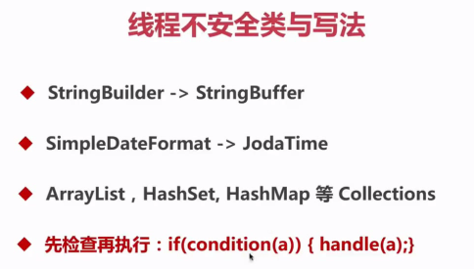

## 同步容器

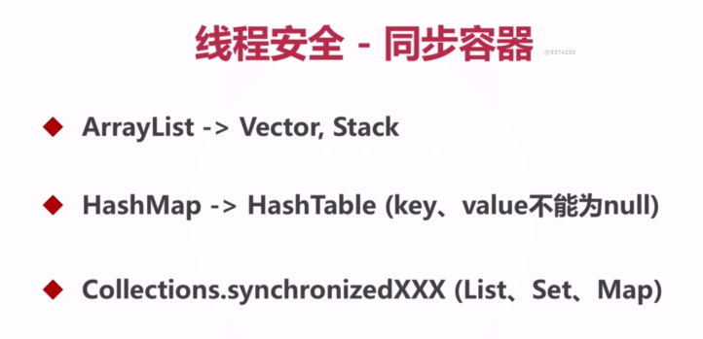

## 线程安全-并发容器J.U.C

Java.util.concurrency

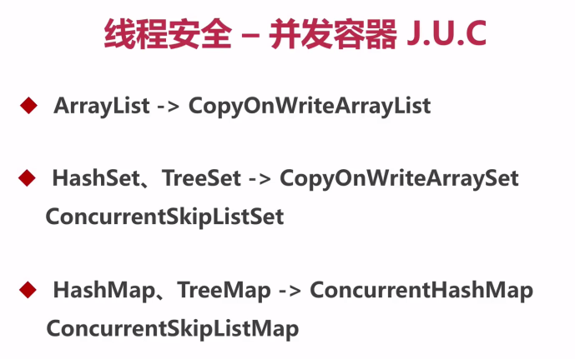

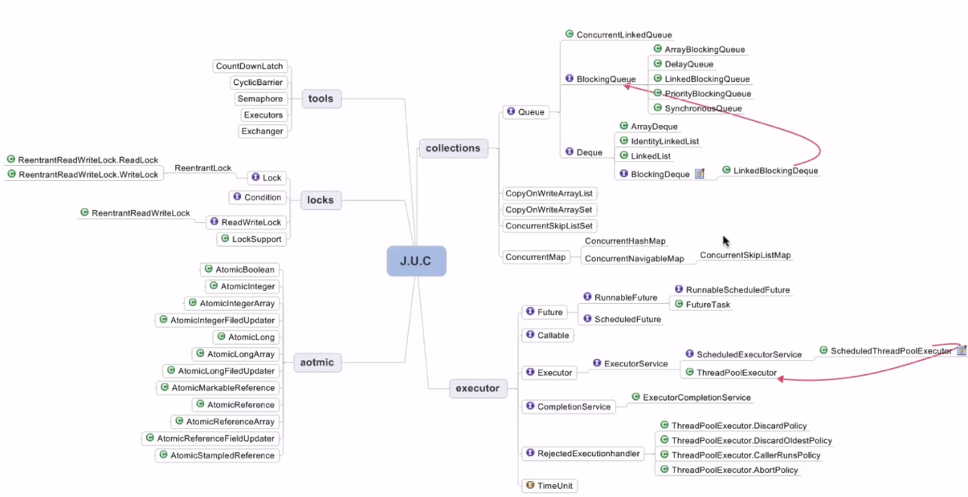

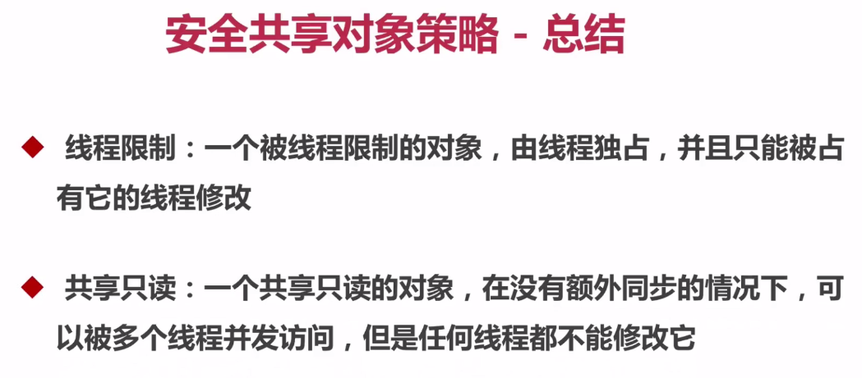

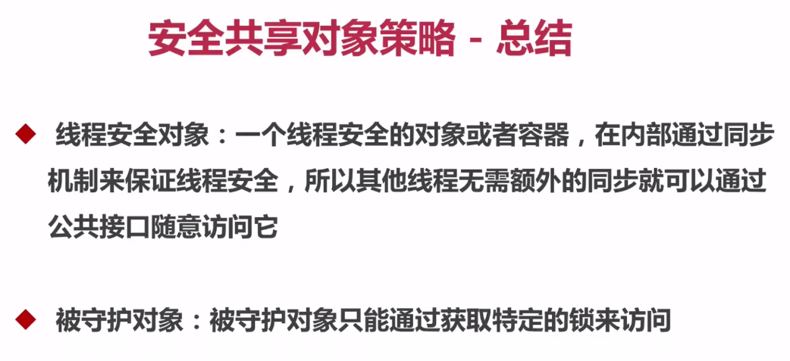

## AQS同步器

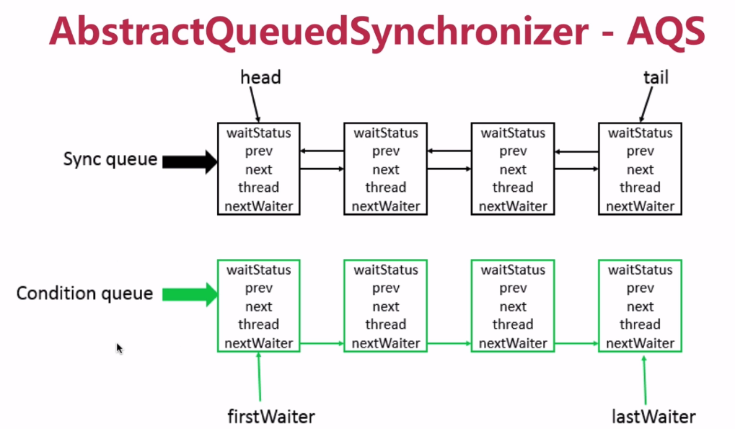

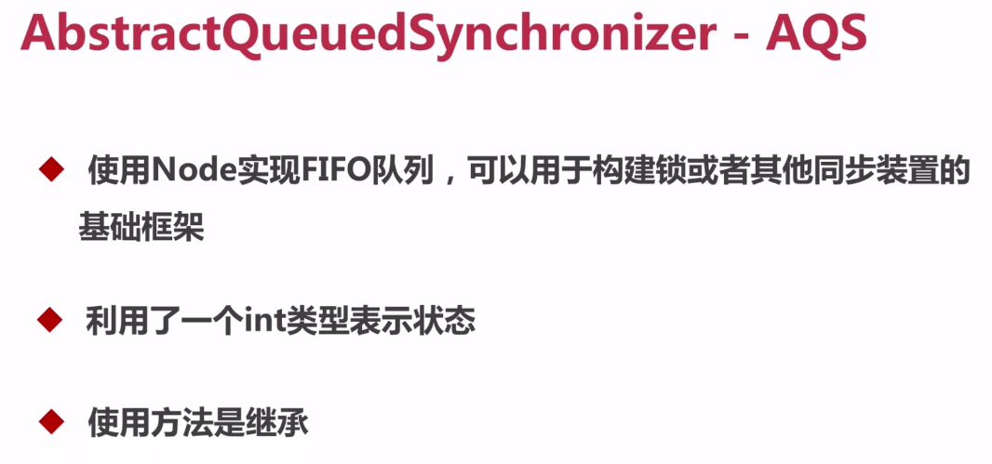

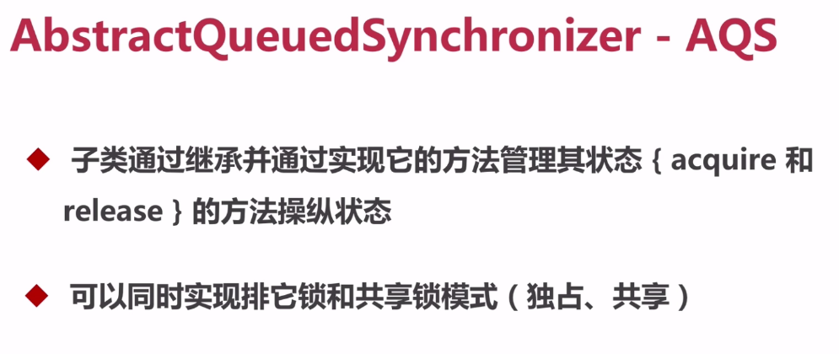

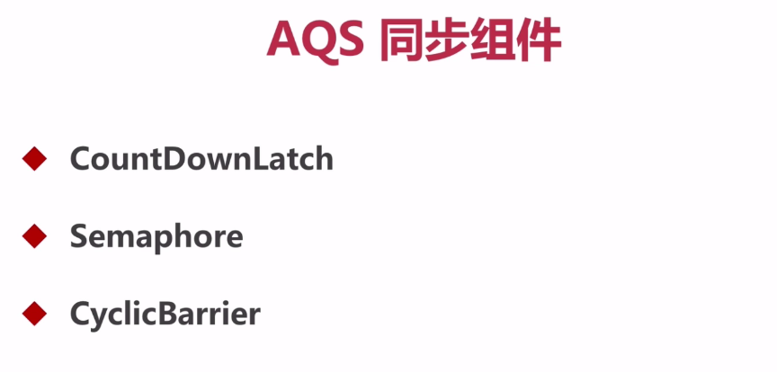

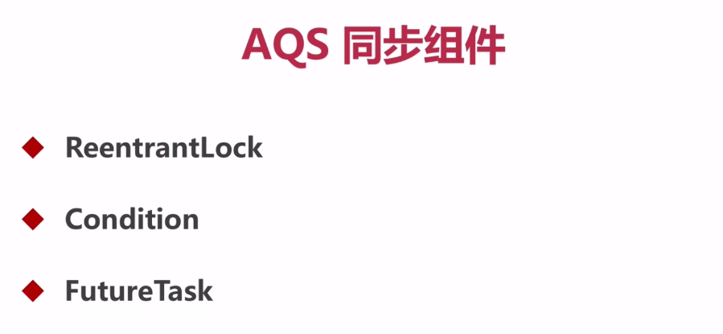

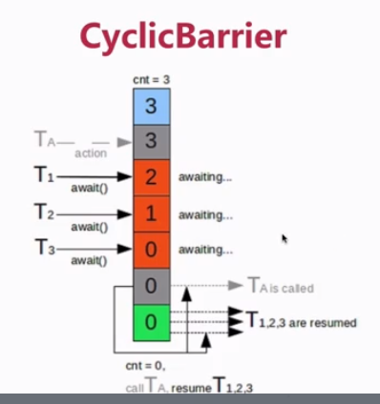

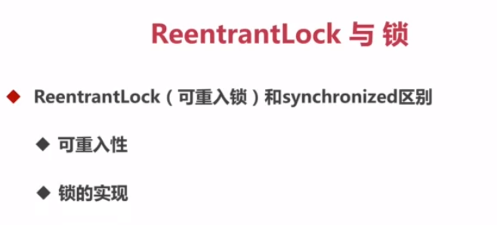

都是可重入的

ReentrantLock JKD实现的

Synchronizd JVM 实现的

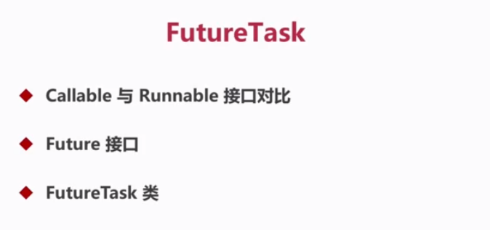

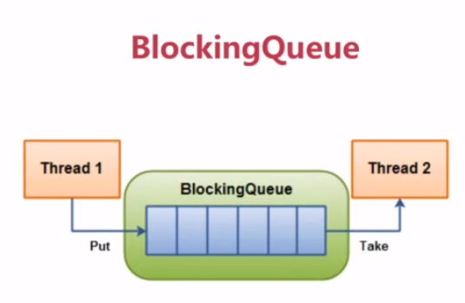

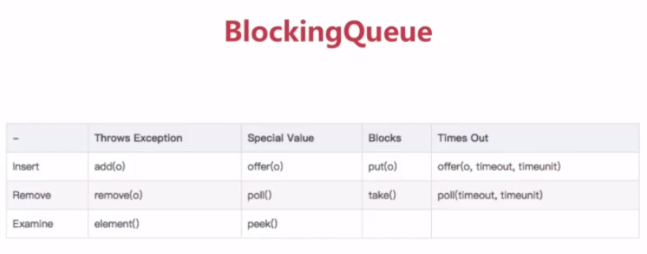

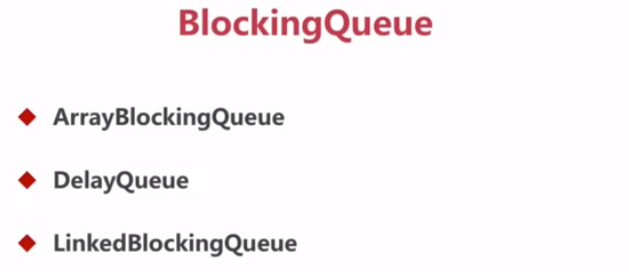

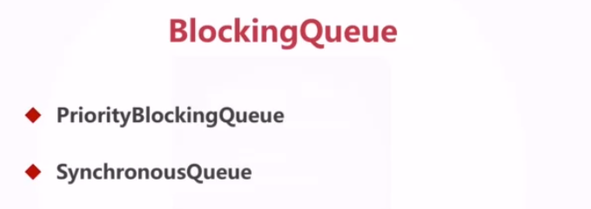

## 线程池



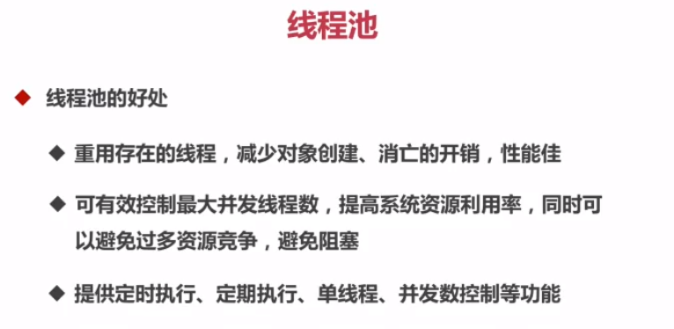

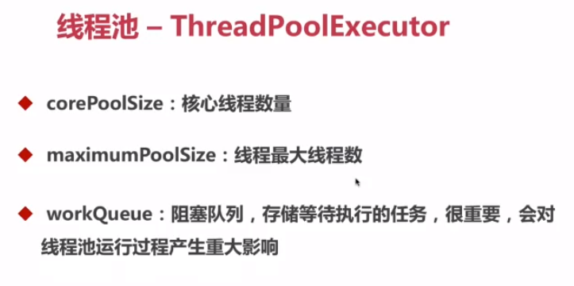

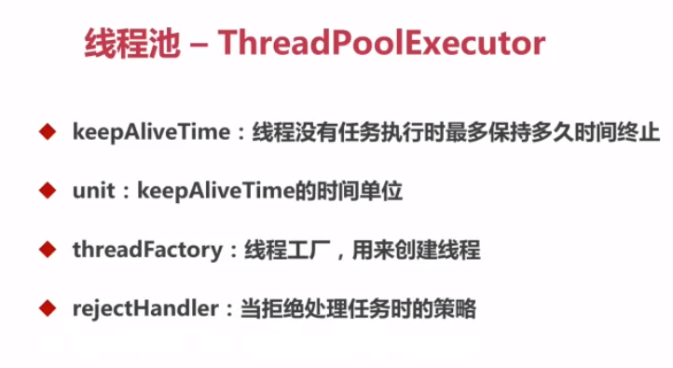

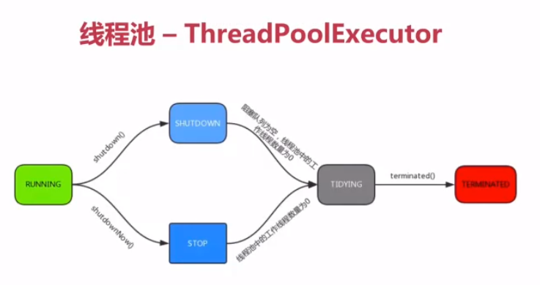

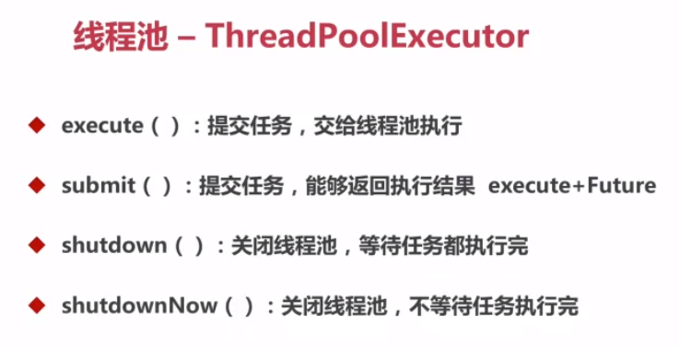

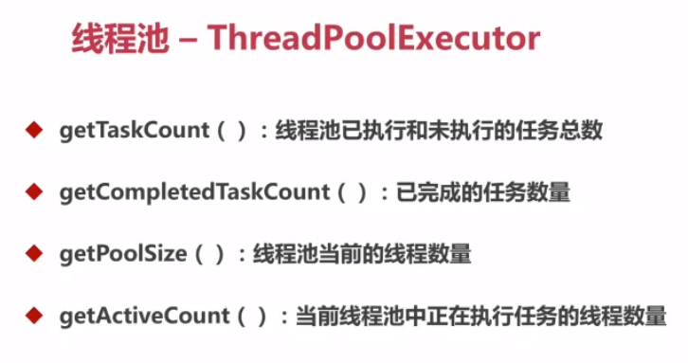

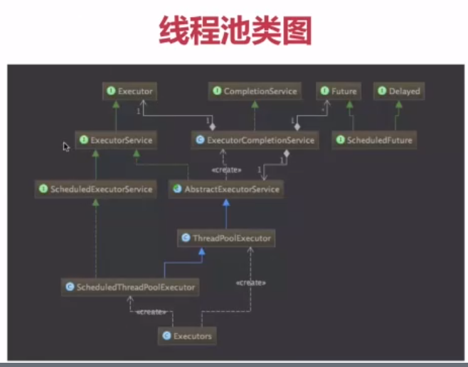

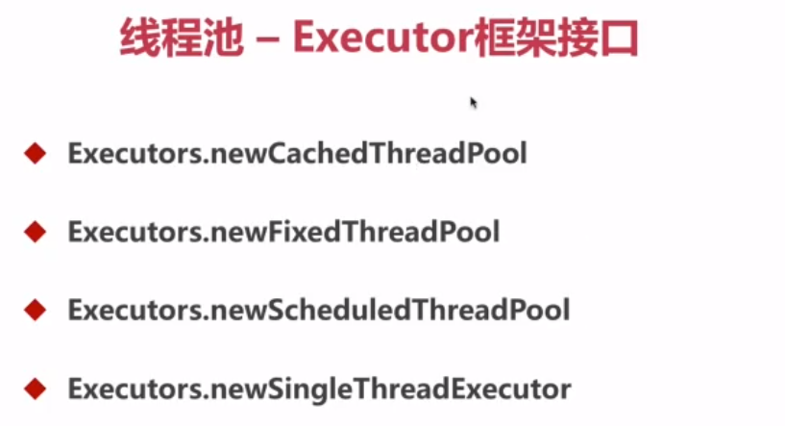

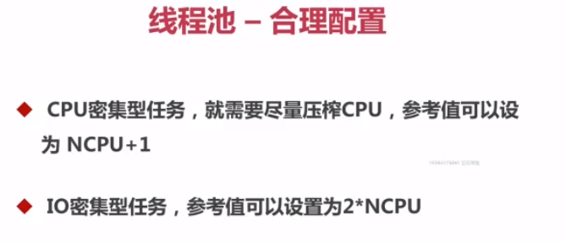

## 死锁

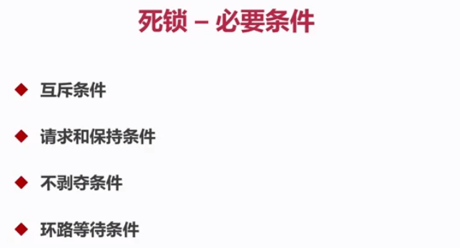

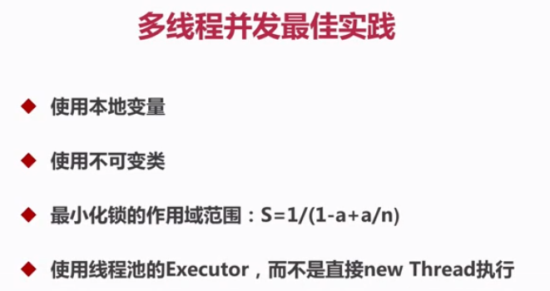

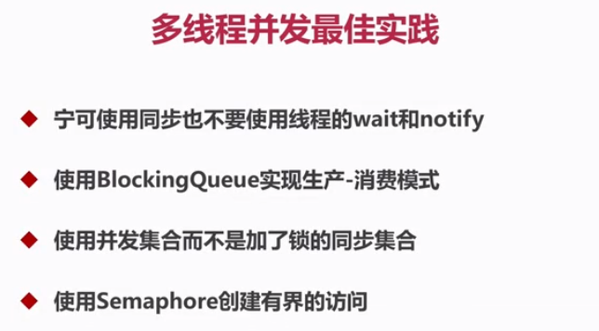

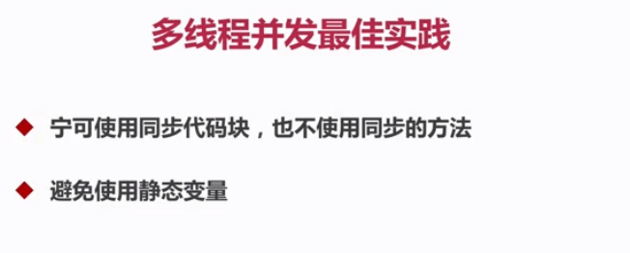

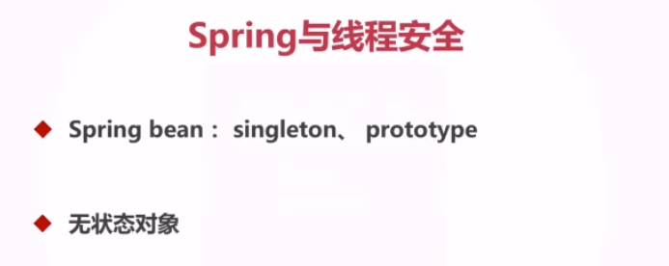

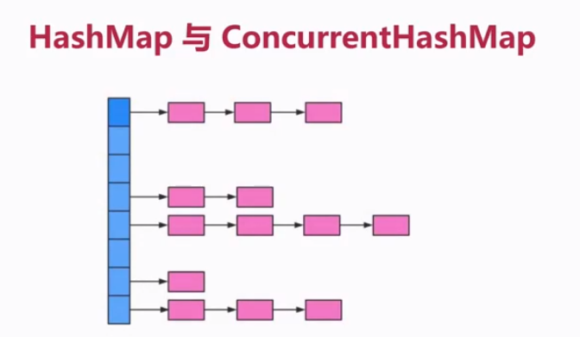

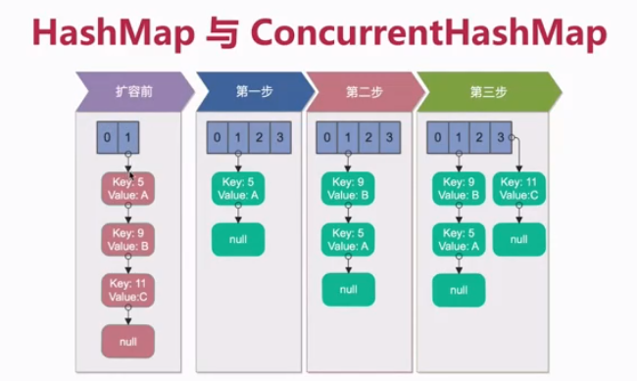

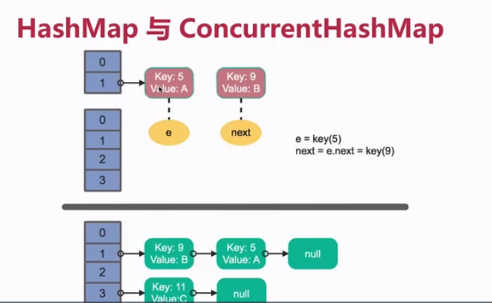

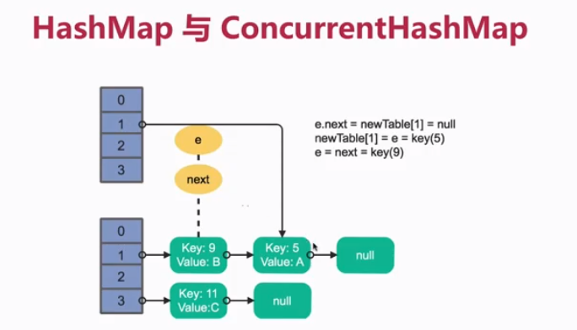

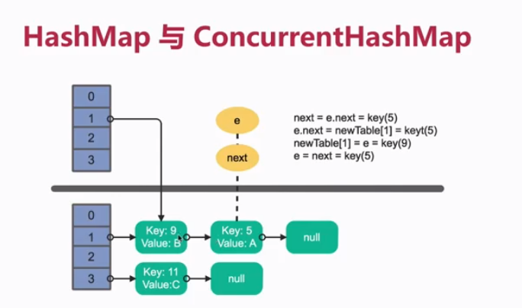

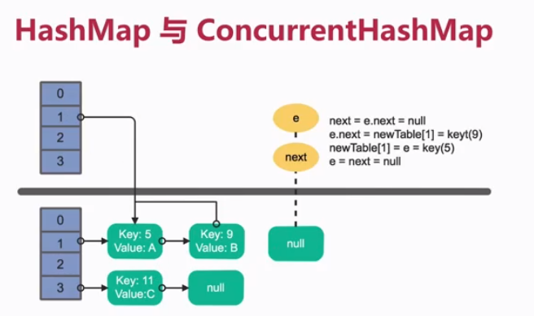

多线程情况下，hashmap在rehash的时候容易出现死循环

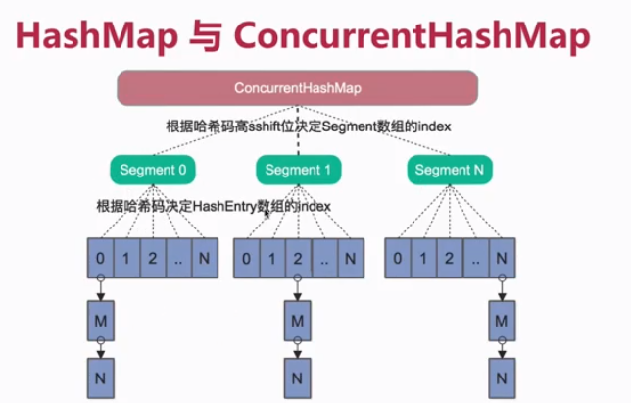

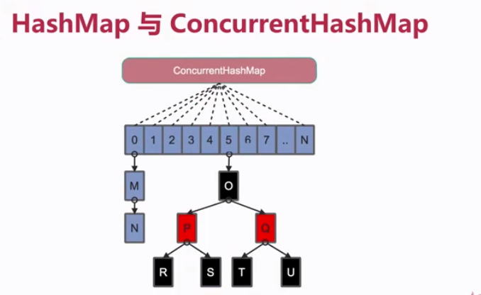

# 2高并发解决方案

思路和手段：

* 扩容
* 缓存
* 队列
* 拆分
* 服务熔断与降级
* 数据库切库
* 分库分表

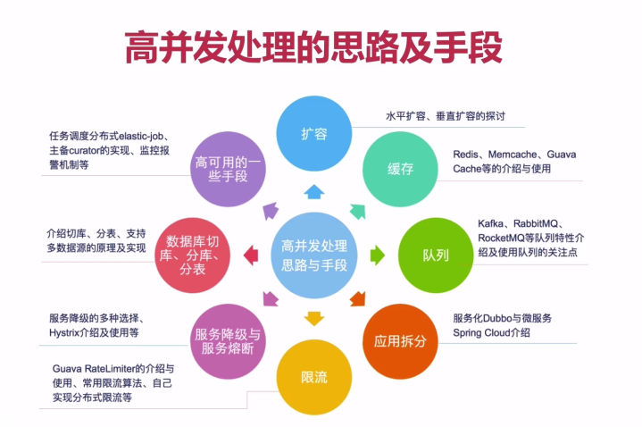

淘宝镜像

<mirrors>

<mirror>

<id>alimaven</id>

<name>aliyun maven</name>

<url>http://maven.aliyun.com/nexus/content/groups/public/</url>

<mirrorOf>central</mirrorOf>

</mirror>

</mirrors>

